SHRI G.S. INSTITUTE OF TECHNOLOGY & SCIENCE

INDORE-452003



MINI PROJECT REPORT

B.E. III YEAR

EI-37991

DEPARTMENT OF ELECTRONICS AND INSTRUMENTATION ENGINEERING

SHRI G.S. INSTITUTE OF TECHNOLOGY & SCIENCE

(An Autonomous Institute Affiliated to RGPV, Bhopal)

DEPT. OF ELECTRONICS & INSTRUMENTATION ENGG.



MINI PROJECT REPORT

ELECTRONIC WORKSHOP 2020-2021

EI-37991

Submitted by: Submitted To:

Name: SHREYA SHUKLA Mr. Virendra Verma Sir

Enroll. No.:0801EI181045 Mr. R.R. Maharana Sir

Branch: EIE Ms. Neha Pande Ma’am

Subject: Mini Project Report

Class: B.E. III year

Semester: VIth

**CERTIFICATE**

This is to certify that Ms. **Shreya Shukla** Enrollment No. 0801EI181045 studying in BE III year VIth semester in Electronics & Instrumentation Engineering department of S.G.S.I.T.S. has successfully made **Mini Project on Batch Processing System** and satisfactory account of it in the report containing a record of the work.

Date: Signature:

**Acknowledgement**

I would like to express my special thanks of gratitude to Mr. Virendra Verma (Asst. Professor), Mr. R.R. Maharana (Asst. Professor) and Ms. Neha Pande (Asst. Professor), who gave me this golden opportunity to do this mini project of Electronic Workshop on “*Batch Processing System*”, who also helped me in completing my project. I came to know about so many things I am really thankful to them. Secondly, I would also like to thank my parents and friends who helped me a lot in finalizing this project within the limited time frame.

**CONTENTS**

|  |  |  |
| --- | --- | --- |
| **S. No.** | **Topics** | **Page no.** |
| 1.0 | **BATCH PROCESSING SYSTEM** | 6 |
| 1.1 | Introduction | 6-7 |
| 1.2 | Circuit Diagram | 8 |
| 1.3 | Component list | 9 |
| 1.4 | Component description | 10-23 |
| 1.5 | Circuit Operation | 24-25 |
| 1.6 | Arduino Sketch | 26-27 |
| 1.7 | Project Picture | 27 |
| 1.8 | Conclusion | 28 |
| 1.9 | Reference | 28 |
|  |  |  |

Project Report on Batch Processing System

**INTRODUCTION**

**Batch production** is a method of manufacturing where the products are made as specified groups or amounts, within a time frame. A batch can go through a series of steps in a large manufacturing process to make the final desired product. Batch production is used for many types of manufacturing that may need smaller amounts of production at a time to ensure specific quality standards or changes in the process. This is opposed to large  or [continuous production](https://en.wikipedia.org/wiki/Continuous_production) methods where the product or process does not need to be checked or changed as frequently or periodically.

In the manufacturing batch production process, the machines are in chronological order directly related to the manufacturing process. The batch production method is also used so any temporary changes or modifications can be made to the product if necessary, during the changed, it can be done in between batches. As opposed to assembly production or mass production where such changes cannot be easily made. The time between batches is called cycle time. Each batch may be assigned a [lot number](https://en.wikipedia.org/wiki/Lot_number).

**Advantages**

Because batch production involves small batches, it is good for quality control. For example, if there is a mistake in the process, it can be fixed without as much loss compared to mass production. This can also save money by taking less risk for newer plans and products etc. As a result, this allows batch manufacturing to be changed or modified depending on company needs.

**Disadvantages**

There can be downtime between individual batches. Or if the product is constantly changing or being modified throughout the process, this also can cost downtime. Other disadvantages are that smaller batches need more planning, scheduling and control over the process and collecting data.

**EXPLANATION**



Figure 1. Batch Processing System

A normally open start and normally closed stop pushbuttons are used to start and stop the process. When the start button is pressed, solenoid A energizes to start filling the tank. As the tank fills, the empty level sensor switch closes. When the tank is full, the full-level sensor switch closes. Solenoid A is de-energized. The mixer motor starts and runs for 3 minutes to mix the liquid.  When the agitate motor stops, solenoid B is energized to empty the tank. When the tank is completely empty, the empty sensor switch opens to de-energize solenoid B. The start button is pressed to repeat the sequence.

**CIRCUIT DIAGRAM**

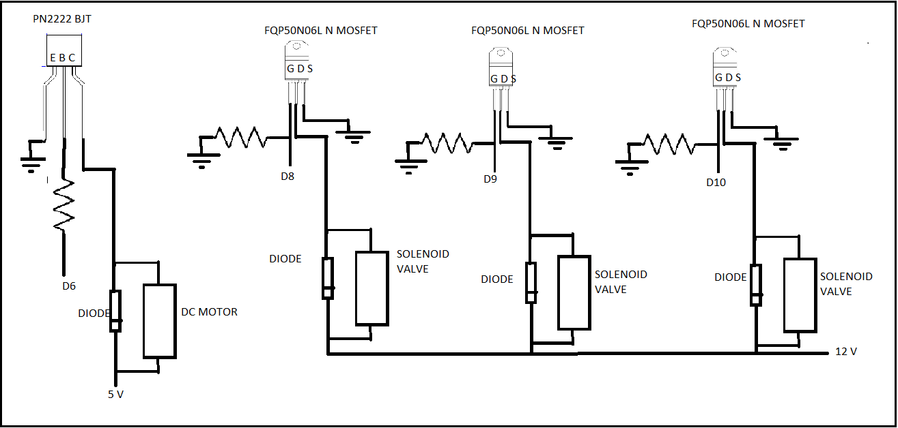

Figure 2. Circuit Diagram

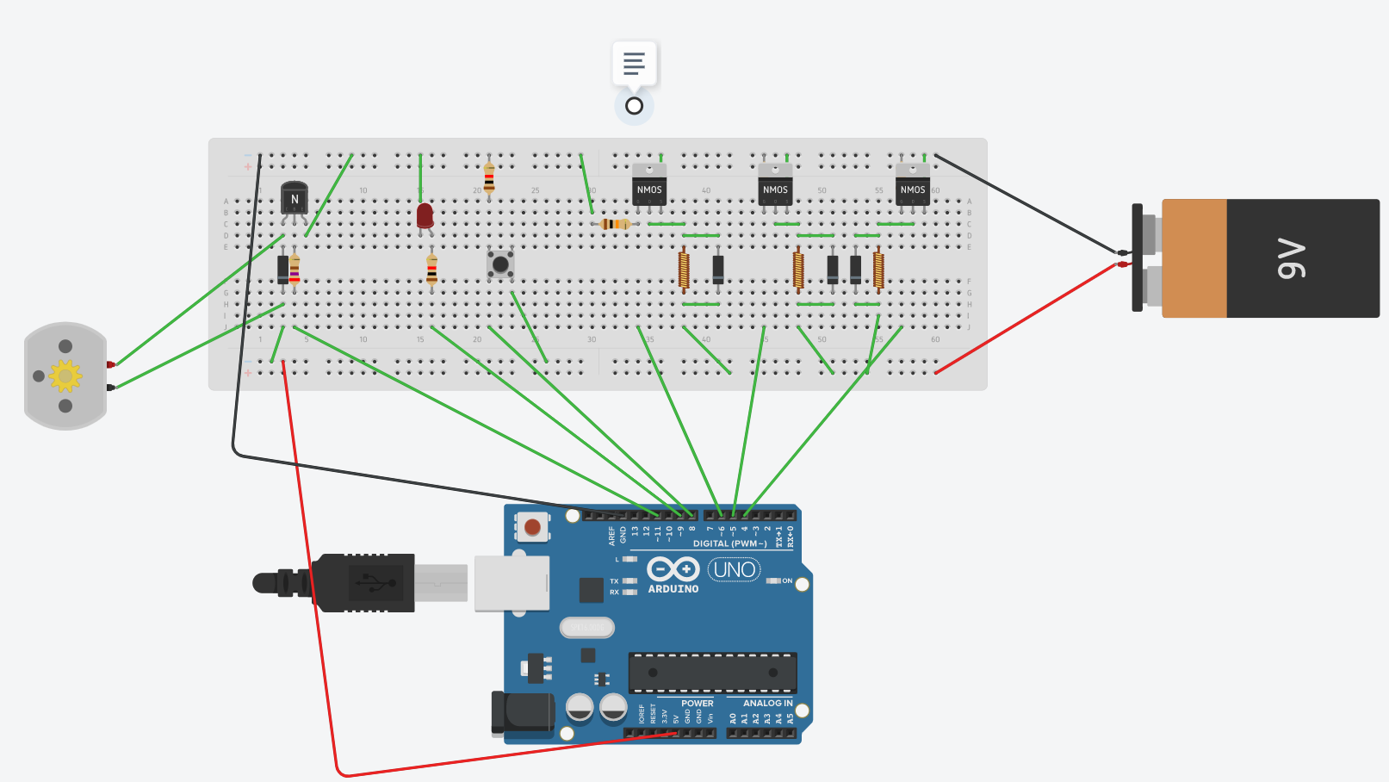

Figure 2. Circuit Diagram ii

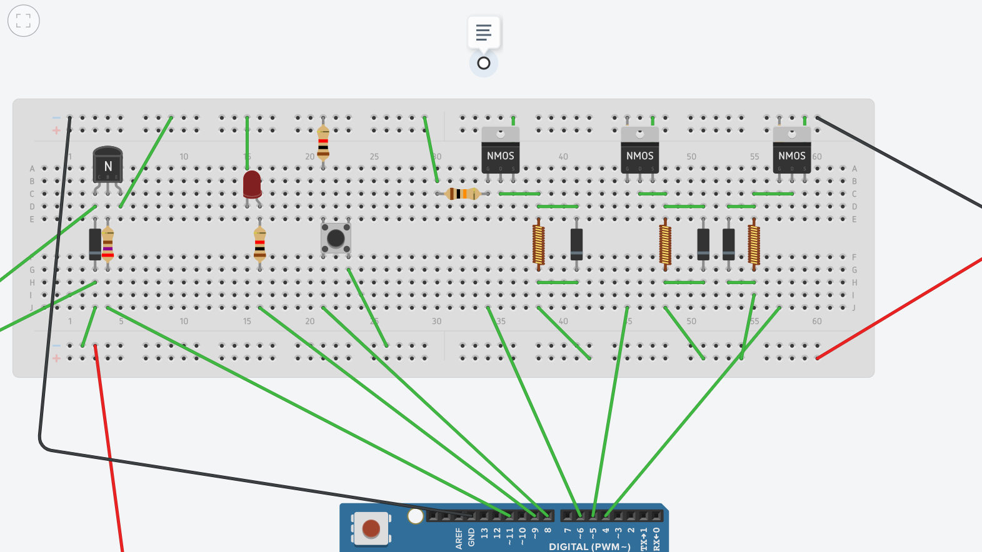

Figure 3. Circuit Diagram iii

**COMPONENTS REQUIRED**

1. Arduino Uno ATmega328P
2. 12 V DC Solenoid valve x3
3. 6V DC Motor
4. Agitator/Toy Fan
5. Breadboard
6. Wires
7. FQP50N06L N-MOSFET x3
8. PN2222 NPN BJT
9. Resistor
   1. 10K ohms x3
   2. 270 ohms
10. IND4007 Diode x4
11. 12V Battery/external power source
12. Pushbutton, LED (optional)
13. Water Level Sensor
14. Container

**COMPONENT DISCRIPTION**

**1.Arduino Uno ATmega328P**

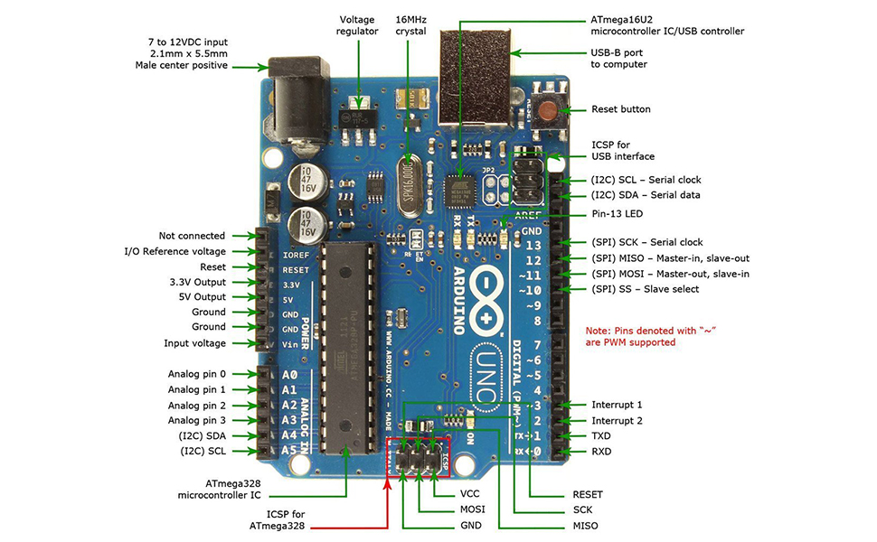

Figure 4. Arduino Uno Development Board

**Arduino Uno** is a microcontroller board based on 8-bit ATmega328P microcontroller. Along with ATmega328P, it consists other components such as crystal oscillator, serial communication, voltage regulator, etc. to support the microcontroller. Arduino Uno has 14 digital input/output pins (out of which 6 can be used as PWM outputs), 6 analog input pins, a USB connection, A Power barrel jack, an ICSP header and a reset button.

**Arduino Uno Technical Specifications**:

|  |  |
| --- | --- |
| Microcontroller | [ATmega328P](https://components101.com/microcontrollers/atmega328p-pinout-features-datasheet) – 8 bit AVR family microcontroller |
| Operating Voltage | 5V |
| Recommended Input Voltage | 7-12V |
| Input Voltage Limits | 6-20V |
| Analog Input Pins | 6 (A0 – A5) |
| Digital I/O Pins | 14 (Out of which 6 provide PWM output) |
| DC Current on I/O Pins | 40 mA |
| DC Current on 3.3V Pin | 50 mA |
| Flash Memory | 32 KB (0.5 KB is used for Bootloader) |
| SRAM | 2 KB |
| EEPROM | 1 KB |
| Frequency (Clock Speed) | 16 MHz |

**Pin Description:**

|  |  |  |
| --- | --- | --- |
| **Pin Category** | **Pin Name** | **Details** |
| Power | Vin, 3.3V, 5V, GND | Vin: Input voltage to Arduino when using an external power source.  5V: Regulated power supply used to power microcontroller and other components on the board.  3.3V: 3.3V supply generated by on-board voltage regulator. Maximum current draw is 50mA.  GND: ground pins. |
| Reset | Reset | Resets the microcontroller. |
| Analog Pins | A0 – A5 | Used to provide analog input in the range of 0-5V |
| Input/Output Pins | Digital Pins 0 - 13 | Can be used as input or output pins. |
| Serial | 0(Rx), 1(Tx) | Used to receive and transmit TTL serial data. |
| External Interrupts | 2, 3 | To trigger an interrupt. |
| PWM | 3, 5, 6, 9, 11 | Provides 8-bit PWM output. |
| SPI | 10 (SS), 11 (MOSI), 12 (MISO) and 13 (SCK) | Used for SPI communication. |
| Inbuilt LED | 13 | To turn on the inbuilt LED. |
| TWI | A4 (SDA), A5 (SCA) | Used for TWI communication. |
| AREF | AREF | To provide reference voltage for input voltage. |

The 14 digital input/output pins can be used as input or output pins by using pinMode(), digitalRead() and digitalWrite() functions in arduino programming. Each pin operate at 5V and can provide or receive a maximum of 40mA current, and has an internal pull-up resistor of 20-50 KOhms which are disconnected by default.  Out of these 14 pins, some pins have specific functions as listed below:

* **Serial Pins 0 (Rx) and 1 (Tx):** Rx and Tx pins are used to receive and transmit TTL serial data. They are connected with the corresponding ATmega328P USB to TTL serial chip.
* **External Interrupt Pins 2 and 3:** These pins can be configured to trigger an interrupt on a low value, a rising or falling edge, or a change in value.
* **PWM Pins 3, 5, 6, 9 and 11:** These pins provide an 8-bit PWM output by using analogWrite() function.
* **SPI Pins 10 (SS), 11 (MOSI), 12 (MISO) and 13 (SCK):** These pins are used for SPI communication.
* **In-built LED Pin 13:** This pin is connected with an built-in LED, when pin 13 is HIGH – LED is on and when pin 13 is LOW, its off.

Along with 14 Digital pins, there are 6 analog input pins, each of which provide 10 bits of resolution, i.e. 1024 different values. They measure from 0 to 5 volts but this limit can be increased by using AREF pin with analog Reference() function.

* Analog pin 4 (SDA) and pin 5 (SCA) also used for TWI communication using Wire library.

Arduino Uno has a couple of other pins as explained below:

* AREF: Used to provide reference voltage for analog inputs with analogReference() function.
* Reset Pin: Making this pin LOW, resets the microcontroller.

**2. SOLENOID VALVE**

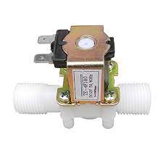 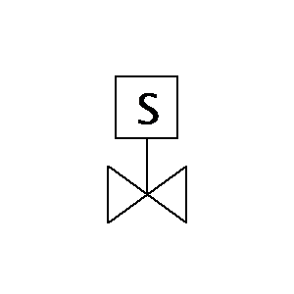

Figure 5. 12 V DC Solenoid Valve Figure 6. Solenoid Valve Symbol

A solenoid valve is an electrically controlled valve. The valve features a solenoid, which is an electric coil with a movable ferromagnetic core (plunger) in its center. In the rest position, the plunger closes off a small orifice. An electric current through the coil creates a magnetic field. The magnetic field exerts an upwards force on the plunger opening the orifice. This is the basic principle that is used to open and close solenoid valves.

Solenoid valves are

* Only used for clean liquids and gases.
* Indirect operated valves require a pressure differential to function.
* Are used to close, open, dose, distribute, or mix the media with 2 or more inlets/outlets.
* Fast acting.
* Can get hot as it requires energy to switch and stay in that position (depending on type).
* Common in heating systems, compressed air, vacuum, irrigation, car washes, etc.

**WORKING OF SOLENOID VALVE**

A solenoid valve consists of two main components: a solenoid and a valve body (G). Figure 7 shows the components. A solenoid has an electromagnetically inductive coil (A) around an iron core at the center called the plunger (E). At rest, it can be [normally open](https://tameson.com/solenoid-valve-types.html#normally-open) (NO) or [normally closed](https://tameson.com/solenoid-valve-types.html#normally-closed) (NC). In the de-energized state, a normally open valve is open and a normally closed valve is closed. When current flows through the solenoid, the coil is energized and creates a magnetic field. This creates a magnetic attraction with the plunger, moving it and overcoming the spring (D) force. If the valve is normally closed, the plunger is lifted so that the seal (F) opens the orifice and allows the flow of the media through the valve. If the valve is normally open, the plunger moves downward so that the seal (F) blocks the orifice and stops the flow of the media through the valve.

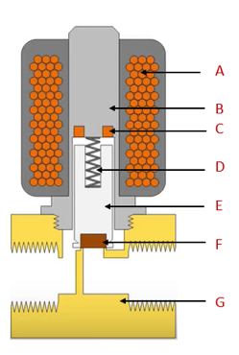

coil (A);

armature (B);

shading ring (C);

spring (D);

plunger (E);

seal (F);

valve body (G)

Figure 7. Components of a solenoid valve



Figure 8. Solenoid Valve Working

**3. DC MOTOR**

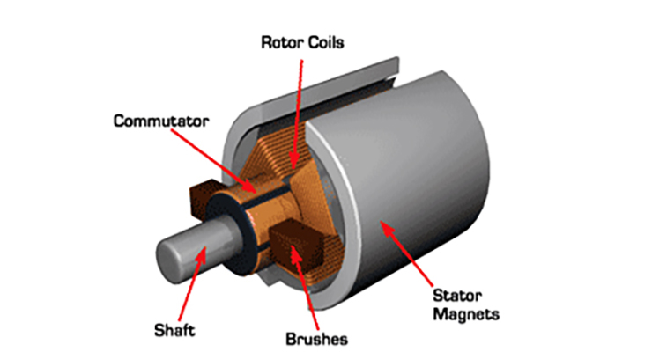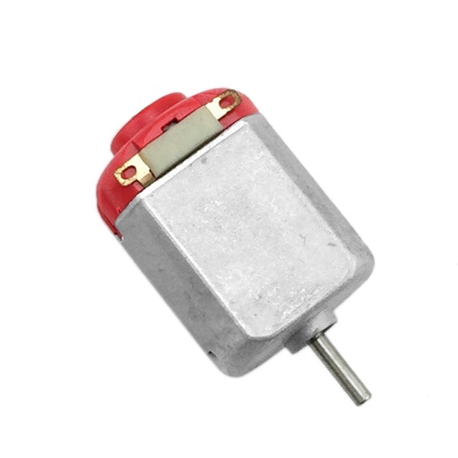

Figure 9. DC Motor Figure 10. 6v dc motor

A DC motor is an electrical machine that converts electrical energy into mechanical energy. In a DC motor, the input electrical energy is the direct current which is transformed into the mechanical rotation.

**Principle of DC Motor**

When a current-carrying conductor is placed in a [magnetic field](https://www.electrical4u.com/magnetic-field/), it experiences a torque and has a tendency to move.

In other words, when a magnetic field and an electric field interact, a mechanical force is produced. The **DC motor** or **direct current motor** works on that principle. This is known as motoring action.

**4. AGITATOR/FAN**

Used with motor.

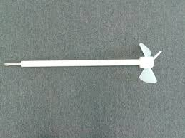

Figure 11. Agitator

**5. BJT- PN2222 NPN**

A Bipolar Junction Transistor (also known as a BJT or BJT Transistor) is a three-terminal semiconductor device consisting of two p-n junctions which are able to amplify or magnify a signal. It is a [current](https://www.electrical4u.com/electric-current-and-theory-of-electricity/) controlled device. The three terminals of the BJT are the base, the collector and the emitter. A BJT is a type of [transistor](https://www.electrical4u.com/working-principle-of-transistor/) that uses both electrons and holes as charge carriers.

A signal of small amplitude if applied to the base is available in the amplified form at the collector of the transistor. This is the amplification provided by the BJT. Note that it does require an external source of [DC](https://www.electrical4u.com/dc-current/) power supply to carry out the amplification process.

A bipolar transistor allows a small current injected at one of its terminals to control a much larger current flowing between two other terminals, making the device capable of amplification or switching

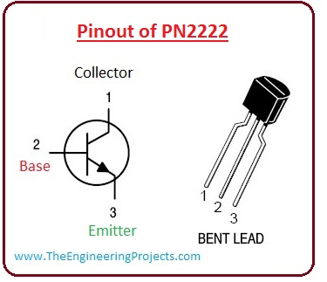

Figure 12. Pin out of PN2222

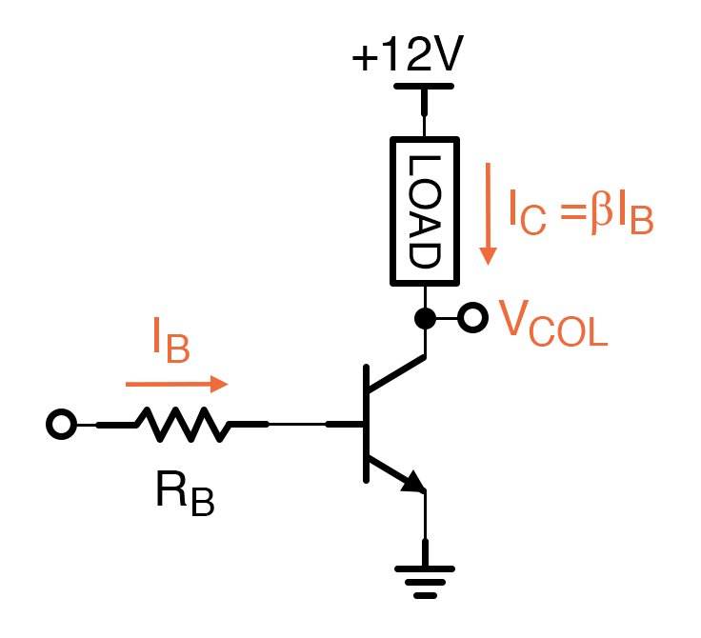

Figure 13. BJT as switch(open)

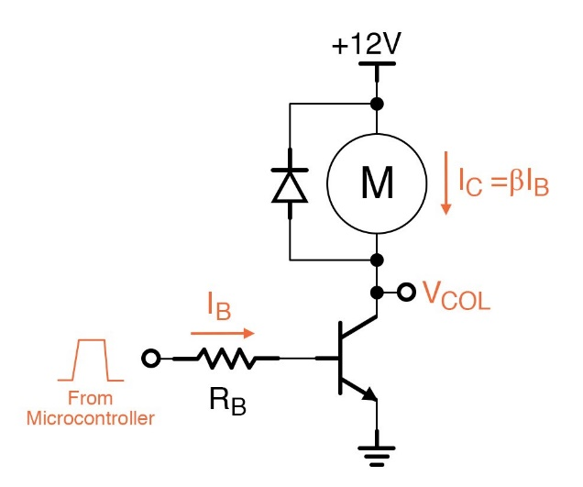

Figure 14. BJT as switch(closed)

* In the figure the circuit shown explains the operation of BJT as a switch.
* In the first circuit, the transistor is in the cutoff region because the emitter-base junction is not forward biased condition.
* In this state, there is no connection between emitter and collector of a transistor as shown like an open switch.
* In the second circuit, a transistor is in a saturation state as both base-collector and the base-emitter junction is in forward biased state.
* The value of base current is such large that it makes collector current such level that transistor is in saturation state.
* In a saturation state, there is a short circuit between emitter and collector as it is shown in a circuit like closes switch configuration.
* In real, a minor voltage loss across the transistor of up to some 10th of a volt usually exits, that is the saturation voltage, VCE(sat).

**6. MOSFET-** **FQP50N06L N MOS**

A metal–oxide–semiconductor field-effect transistor (MOSFET, MOS-FET, or MOS FET) is a field-effect transistor (FET with an insulated gate) where the voltage determines the conductivity of the device. It is used for switching or amplifying signals. The ability to change conductivity with the amount of applied voltage can be used for amplifying or switching electronic signals.

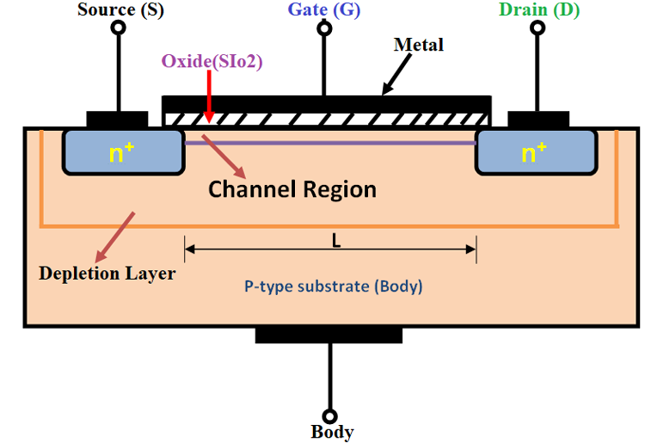

Figure 15. n-MOSFET Structure

Typically, the **MOSFET** is a three-terminal **device** with gate (G), drain (D) and source (S) terminals. Current conduction between drain (D) and source (S) is controlled by a voltage applied to the gate (G) terminal.

* **Depletion Type:** The transistor requires the Gate-Source voltage (VGS) to switch the device “OFF”. The depletion-mode MOSFET is equivalent to a “Normally Closed” switch.
* **Enhancement Type:** The transistor requires a Gate-Source voltage(VGS) to switch the device “ON”. The enhancement-mode MOSFET is equivalent to a “Normally Open” switch.

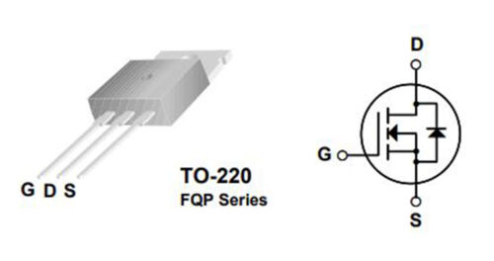

Figure 16. Pin Diagram of FQP50N06L N-Mosfet

FQP50N06L is a N-Channel enhancement mode power MOSFET. This advanced MOSFET technology has been especially tailored to reduce on-state resistance, and to provide superior switching performance and high avalanche energy strength. These devices are suitable for switched mode power supplies, audio amplifier, DC motor control, and variable switching power applications**.**

**MOSFET AS A SWITCH**

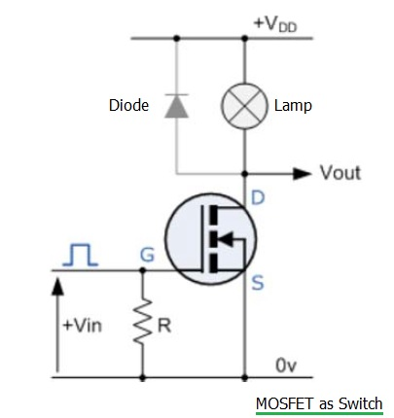

Figure 17. MOSFET as switch

In this circuit arrangement an Enhancement-mode N-channel MOSFET is being used to switch a simple lamp “ON” and “OFF” (could also be an LED).

The gate input voltage VGS is taken to an appropriate positive voltage level to turn the device and therefore the lamp load either “ON”, (VGS = +ve) or at a zero voltage level that turns the device “OFF”, (VGS = 0V).

If the resistive load of the lamp was to be replaced by an inductive load such as a coil, solenoid or relay a “flywheel diode” would be required in parallel with the load to protect the MOSFET from any self generated back-emf.

VGS The voltage range necessary to “turn on” the MOSFET = 1.0- 2.5 V

VCC Voltage of the I/O pin used (VGS must be less) = 5.0 V

VDS The maximum operational voltage for the load side = 60 V

VLOAD Voltage of whatever you are trying to control (VDS must be more) = 12 V

**7. DIODE- IN4007**

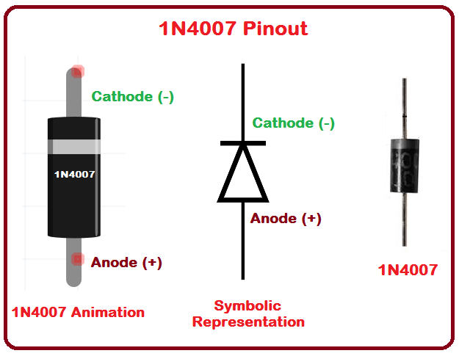

Figure 18. Pin out of diode IIN4007

A **diode** is defined as a two-terminal electronic component that only conducts current in one direction (so long as it is operated within a specified voltage level). An ideal **diode** will have zero resistance in one direction, and infinite resistance in the reverse direction.

**8. BREAD BOARD**

A breadboard is a solderless device for temporary prototype with electronics and test circuit designs. Most electronic components in electronic circuits can be interconnected by inserting their leads or terminals into the holes and then making connections through wires where appropriate.

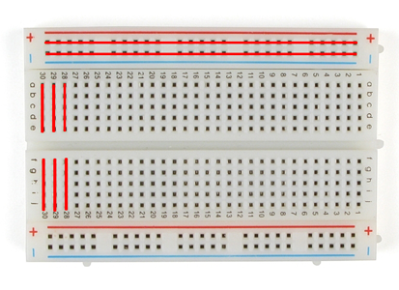

Figure 19. BreadBoard

**9. JUMPER WIRES**

A jump wires (also known as jumper wire, or jumper) is an electrical wire, or group of them in a cable, with a connector or pin at each end (or sometimes without them – simply "tinned"), which is normally used to interconnect the components of a breadboard or other prototype or test circuit, internally or with other equipment or components, without soldering.

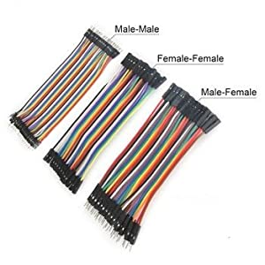

Figure 20. Jumper Wires

**10. RESISTOR**

A resistor is a passive two-terminal electrical component that implements electrical resistance as a circuit element. In electronic circuits, resistors are used to reduce current flow, adjust signal levels, to divide voltages, bias active elements, and terminate transmission lines, among other uses.

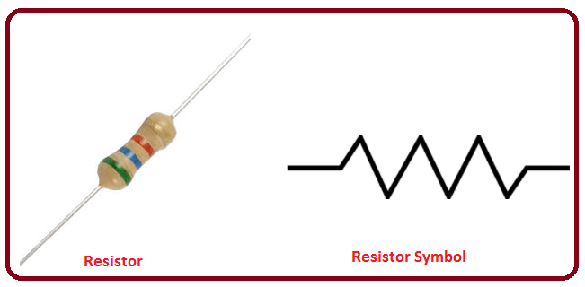

Figure 21. Resistor Symbol

**11. WATER LEVEL SENSOR MODULE**

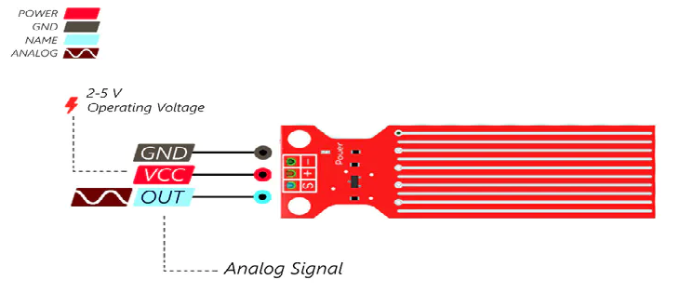

Figure 22. Water level sensor Module Pinout

The sensor has a series of ten exposed copper traces, five of which are power traces and five are sense traces.

These traces are interlaced so that there is one sense trace between every two power traces.Usually these traces are not connected but are bridged by water when submerged.

The resistance is inversely proportional to the height of the water:

* The more water the sensor is immersed in, results in better conductivity and will result in a lower resistance.
* The less water the sensor is immersed in, results in poor conductivity and will result in a higher resistance.

The sensor produces an output voltage according to the resistance, which by measuring we can determine the water level.

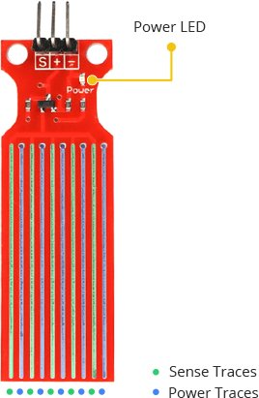

Figure 23. Working of water level sensor Figure 24. Water Level Sensor

**CIRCUIT OPERATION**

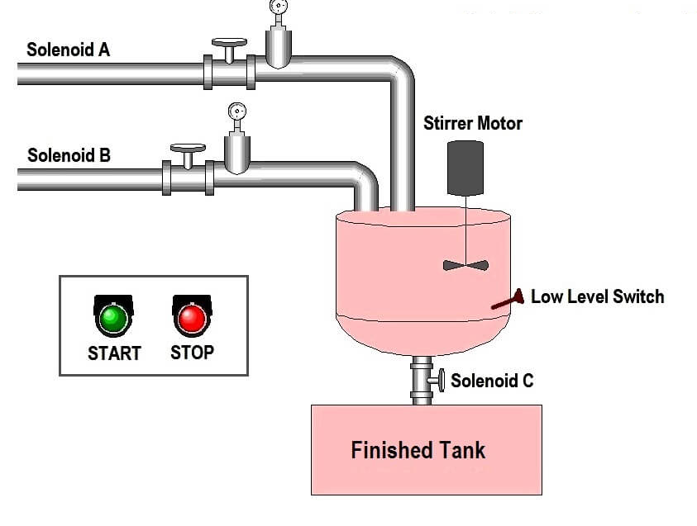

Figure 25. Batch Processing System

1. Ingredient A is sent to the tank first by energizing solenoid A. Solenoid Valve will be open until 2/5th has poured in.
2. After ingredient A is in the tank, 3/5th of ingredient B should be added. The process of adding follows the same procedure as ingredient A.
3. Once step 2 is done, the mixer motor starts and runs for 4s.
4. After mixing is complete, solenoid 3 should open, let the mixed batch goes to the finished tank.
5. When the tank is empty, the low-level sensor turns ON to open solenoid 3 to close and restarts the process again.

**Application:**

**Automated Colour Mixing Process**

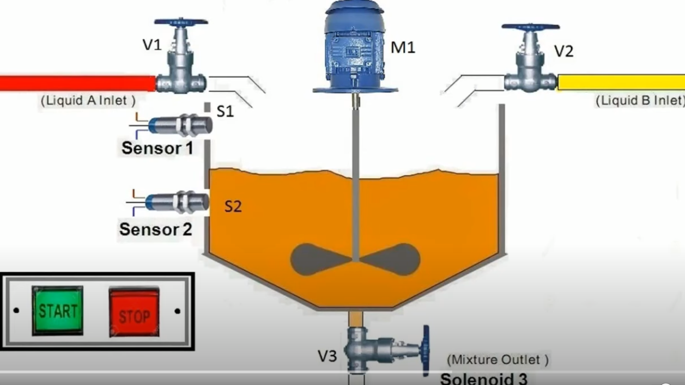

Figure 26. Automated Colour Mixing Process

**ARDUINO SKETCH**

// BATCH PROCESSING SYSTEM

const int solenoid1=10;

const int solenoid2=9;

const int solenoid3=8;

const int motor=6;

const int led=13;

const int sensorPin= A0;

int val = 0; // Value for storing water level

void setup()

{

pinMode(solenoid1,OUTPUT);

pinMode(solenoid2,OUTPUT);

pinMode(solenoid3,OUTPUT);

pinMode(motor,OUTPUT);

pinMode(led,OUTPUT);

// pinMode(buttonPin,INPUT);

Serial.begin(9600);

}

void loop()

{

digitalWrite(led,HIGH);

delay(1000);

digitalWrite(solenoid1, HIGH); // turn on solenoid1 for 2 seconds to fill up 2/5th part of the mixture

delay(2000); // Wait for 2000 millisecond(s)

digitalWrite(solenoid1, LOW);

delay(2000); // Wait for 2000 millisecond(s)

digitalWrite(solenoid2, HIGH); // turn on solenoid2 for 3 seconds to fill up 3/5th part of the mixture

delay(3000); // Wait for 3000 millisecond(s)

digitalWrite(solenoid2, LOW);

delay(2000); // Wait for 2000 millisecond(s)

val = analogRead(sensorPin); //read input value

Serial.print("Water level: ");

Serial.println(val);

if(val>100) // if water level value>100, turn on motor for 4 seconds

{

digitalWrite(motor, HIGH);

delay(4000);

digitalWrite(motor, LOW);

delay(2000);

digitalWrite(solenoid3, HIGH); // turn on selenoid3 for 5 seconds to drain the mixture

delay(5000); // Wait for 5000 millisecond(s)

digitalWrite(solenoid3, LOW);

delay(2000); // Wait for 2000 millisecond(s)

}

digitalWrite(led,LOW);

delay(1000);

}

**PROJECT PICTURE**

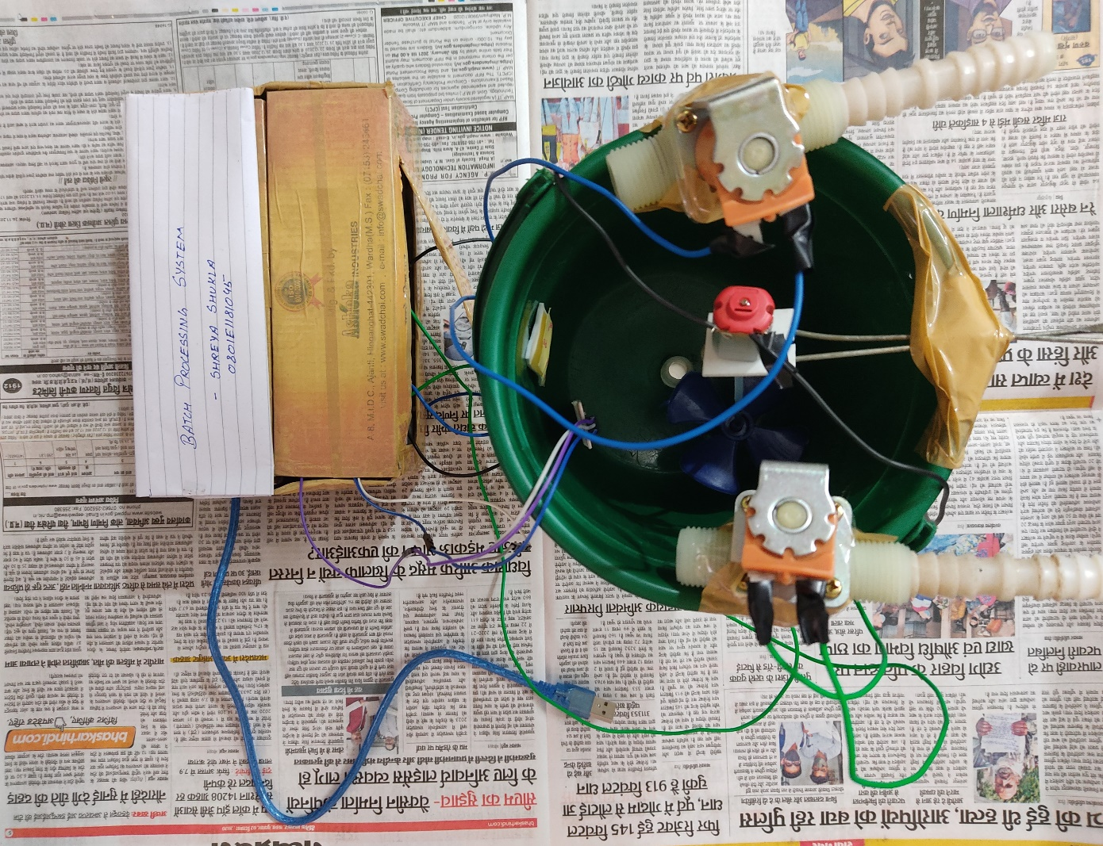

Figure 27. Project Picture

**CONCLUSION**

Batch Processing System using Arduino uno ATMEGA328P and solenoid valve is made, which is widely used in industries used for mixing components of different proportions, properties, colour etc.

Schematic, components list, component description, working, Arduino sketch all is described.

**REFERENCE:**

* PN2222 BJT, FQP50N06L NMOSFET Data Sheet
* <https://www.solenoidsolutionsinc.com/infographics/how-a-2-way-normally-closed-solenoid-valve-works/#:~:text=A%202%2Dway%2C%20normally%20closed,Turn%20off%20the%20power>
* <https://www.electronicsforu.com/resources/mosfet-basics-working-applications>
* <https://microcontrollerslab.com/water-level-sensor-interfacing-arduino/>
* <https://accautomation.ca/plc-programming-example-process-mixer/#:~:text=How%20does%20the%20process%20mixer,empty%20level%20sensor%20switch%20closes>
* <https://youtu.be/o4_NeqlJgOs>
* <https://youtu.be/WRm2oUw4owE>
* <https://youtu.be/sRVvUkK0U80>
* <http://www.martyncurrey.com/controlling-a-solenoid-valve-from-an-arduino-updated/>
* <https://youtu.be/GrvvkYTW_0k>
* <https://forum.arduino.cc/index.php?topic=97854.0>
* <https://www.instructables.com/Controlling-a-DC-Motor-With-Arduino/>
* <https://youtu.be/Xe-Csmw9mb8>
* <https://bc-robotics.com/tutorials/>
* <https://lastminuteengineers.com/water-level-sensor-arduino-tutorial/>
* <https://instrumentationtools.com/plc-programming-batch-process>

***THE END***

***THANK YOU!!***